Name: _____________________ Class:__________ Date:__________
Instructions: Write answers in the right-hand column. Score: ___________ / 52 marks
Section A— Multiple choice (10 marks)

 | Two forces stretch a cable within a structure. Which of the following best describes the cable?  A The cable is in compression.  B The cable is in tension.  C The cable is being stretched by gravity.  D The cable is unbalanced. | b | 1
 | When a door or window sticks it indicates that the structure:  A has partly failed  B has forces acting on it  C has all of its forces balanced  D has no forces acting on it | a | 1
 | An aircraft is flying in a straight line at constant altitude and at a constant speed. What can be said about the forces on the aircraft?  A The forces are unbalanced.  B The forces are balanced.  C The forces are compression forces.  D The aircraft is accelerating. | b | 1
 | When standing, your legs are in:  A compression  B tension  C failure  D friction | a | 1
 | Sandstone is a building material that is strong under:  A compression only  B tension only  C both compression and tension  D all forces | a | 1
 | A cable is stretched by a tensile force of 20 MN (20 000 000 N). The cross-sectional area of the cable is 0.5 m². The stress in the cable is:  A 0.025 m²/MN  B 40 N/m²  C 40 MN/m²  D 40 000 000 MN/m² | c | 1
 | Which of the following stick people would be unstable and most likely to topple over? | d | 1
  A | 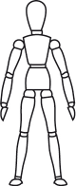 | B | 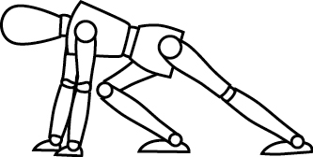
  C | 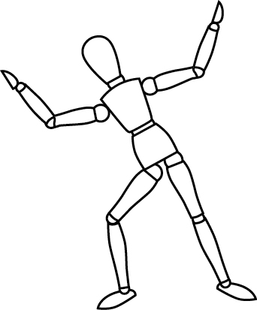 | D | 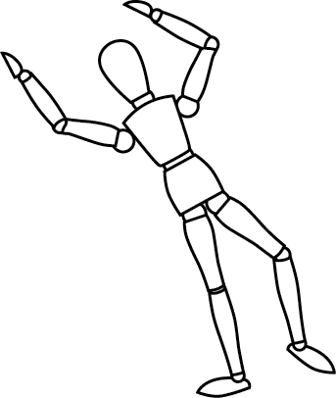
 | Which of the following best describes a lintel?  A Lintels are beams commonly used over doors and windows.  B Lintels are used to support the walls of Gothic arches.  C Lintels are domes.  D Lintels are made up of steel triangles. | a | 1
 | Describe what a flying buttress is.  A A flying buttress is commonly used to support the walls of a Gothic arch.  B A flying buttress is commonly used in bridges.  C Windows commonly have a flying buttress supporting the wall above them.  D A flying buttress is a type of skyscraper. | a | 1
 | The Sydney Harbour Bridge is an example of a:  A bowstring arch bridge  B cable-stayed bridge  C suspension bridge  D beam bridge   | a | 1

Section B— Short answer (32 marks)

 | Classify the following as situations in which forces are balanced or unbalanced:  a A motorbike is accelerating away from traffic lights.  b A car is travelling at 100 km/h straight down a freeway.  c A surfer falls off their surfboard.  d A bird flies into a window and bounces off. | a Unbalanced.  b Balanced.  c Unbalanced.  d Unbalanced. | 4
 | Construct diagrams showing forces:  a in compression  b in tension. | a Any diagram in which there are two forces pointing towards each other.  b Any diagram in which there are two forces pointing away from each other. | 2
 | Explain why a stretched cable is most likely to break at a scratch. | In an unscratched cable, the cross-sectional area is constant along the whole length of the cable. Hence, the stress is constant too. Any scratch reduces the cross-sectional area and so the stress at the scratch increases, stretching the cable there and thinning it even more. Eventually the stress at the scratch is so high that the cable breaks there. | 4
 | Describe a simple way of determining whether part of a structure is in compression or tension. | Imagine that the part of the structure has been replaced with a length of rope. If under tension, then the rope will be taut. If under compression, then the rope will collapse and form S bends. | 2
- ` | Classify each of the components (labelled a, b and c) in the structure below as being in compression or tension.  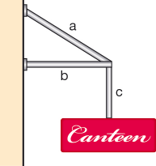 | a tension  b compression  c tension | 3
 | When a structure fails, it doesn’t always fall down. Describe two ways you can tell that some minor failure has occurred in a structure. | Cracking/jammed windows and doors | 2
 | Use a diagram to explain why trucks are more likely to topple over than cars when on a slope. | Trucks have a higher centre of mass than cars. Hence it is more likely for the weight force of a truck than a car to pass outside the base formed by their wheels.  Diagram needs to show:  - that a truck has a higher centre of mass than a car.  - that when on a slope, the weight force of the truck can pass outside its base while the weight force of the car passes within its base. | 2
 | a Describe four different ways the total height of a skyscraper can be measured.  b State which way is usually used to measure buildings. | a Skyscrapers can be measured to:  ● the very tip of the building  ● the top of its roof  ● the highest occupied floor  ● the highest part of the building but not including ‘add-ons’ such as TV antennae, radio masts, satellite dishes or flagpoles.  b Most buildings are measured this way to the highest part of the building, not including ‘add-ons’. | 5
 | a Compare reinforced concrete with ‘normal’ unreinforced concrete.  b Explain why reinforced concrete is far better than ‘normal’ unreinforced concrete in structures. | a Reinforced concrete is ‘normal’ concrete but poured over steel bars or mesh.  b Normal concrete is strong under compression but weak under tension. This makes it good for many foundations and columns but not good for beams and floors. The reinforcing steel rods or mesh makes it strong under tension as well as compression. | 3
 | Identify each of the following structures by matching them with one of the terms in the box. | a Gothic arch  b Roman arch  c Post and beam  d Truss  e Flying buttress | 5
  Flying buttress
  Roman arch
  Gothic arch
  Truss
  Post and beam
  a | 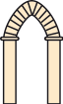
  b | 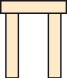
  c | 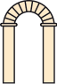
  d | 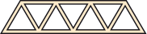
  e | 

Section C—Thinking scientifically (10 marks)

 | A cable was placed under tension until just before it broke. Which of the following diagrams best shows the cable just before it broke?  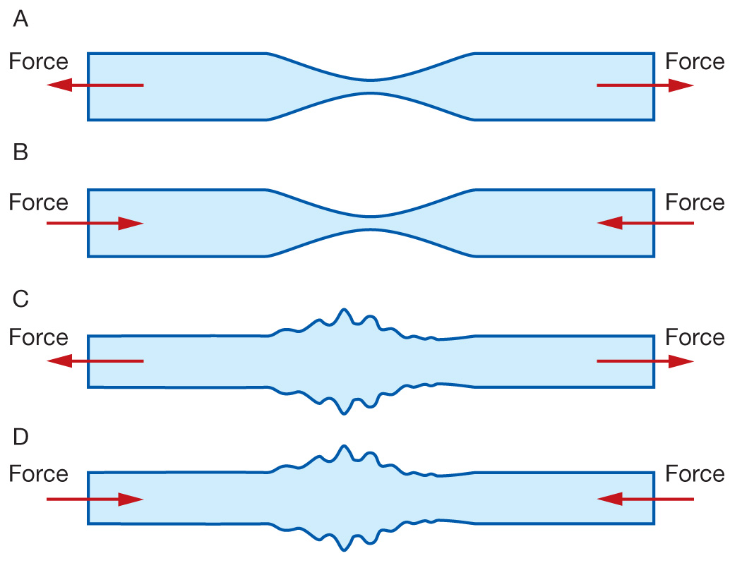 | a | 1
 | A beam sags and bends under its own weight and the weight of anything that is placed on top of it. Which of the following diagrams best shows a beam just before it fails?  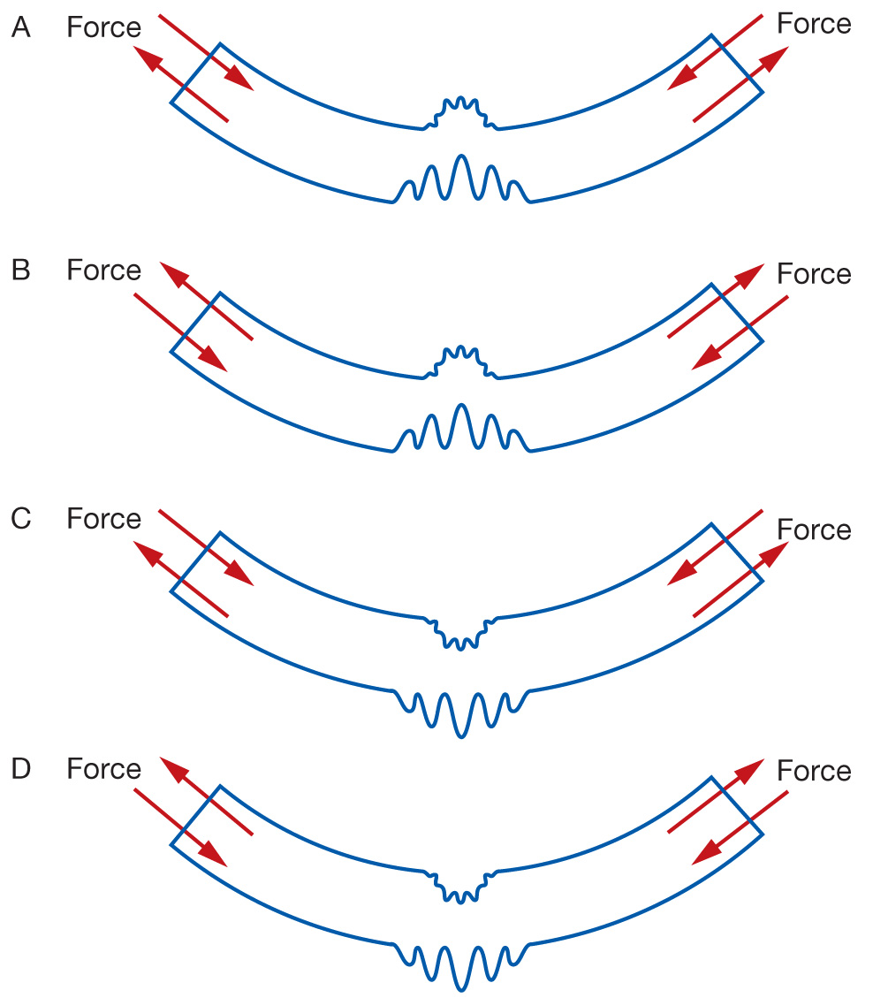 | a | 1
 | A cable was stretched until it broke by adding weights to it. The graph showing how much it stretched as weights were added is shown below. Identify which of the points on the graph (A, B, C or D) represents the point at which the cable broke.  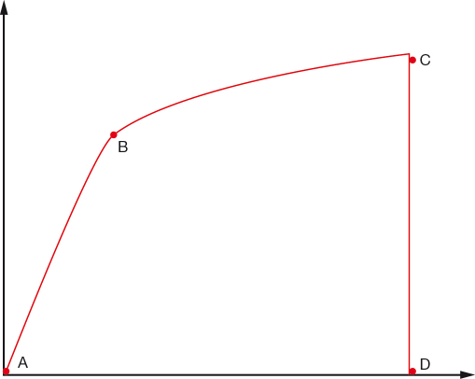 | c | 1
 | An arch is to be built using blocks of stone. Four stonemasons produced different sets of stones to construct the arch. Each set had nine identical stones but each set was a different shape. The shapes are shown below. Which shape of stone would be best to use for the arch?  A B  C D | a | 1
 | A heavy statue is placed on top of a column. What forces are in the column?  A compression  B tension  C friction  D buoyancy | a | 1
 | A shop sign is shown below. Identify which component of the sign is in compression.  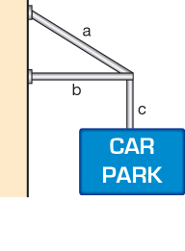  A component a  B component b  C component c  D insufficient information to decide | b | 1
 | A shop veranda is to be supported with a flexible steel cable. Identify which of the following designs would provide the best support.  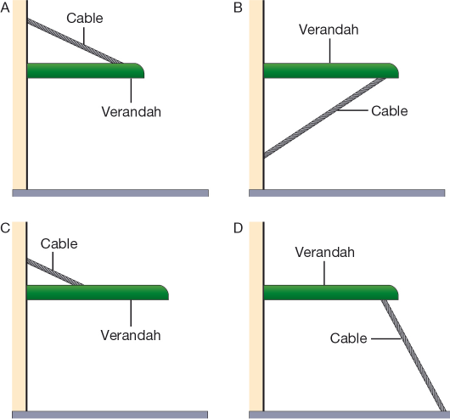 | A | 1
 | The angle of repose of a material is the maximum angle a cone of material can make before it collapses. The angles of repose for sand, gravel and loose gravel are shown below.  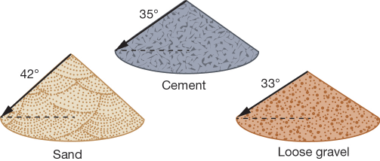  Identify which of the following angles of cones of gravel would be most likely to stand upright without collapsing.  A 42°  B 30°  C 33°  D 35° | b | 1
 | Identify which of the following would be the steepest if built to their maximum angles of repose.  A cone of sand  B cone of cement  C cone of loose gravel  D insufficient information to decide | a | 1
 | A truck is passing along a bridge like the one shown below. State where the truck is when the compression in both columns is exactly the same.  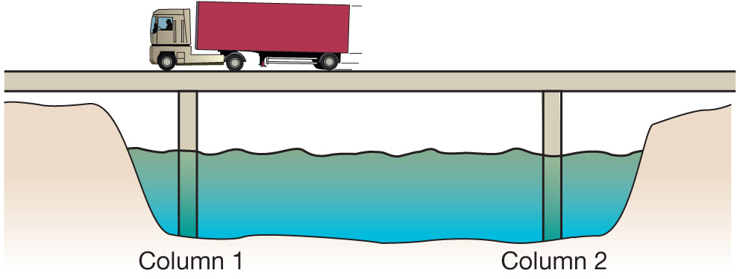  A above column 1  B above column 2  C halfway between column 1 and column 2  D closer to column 1 than column 2 because the truck is travelling in that direction | c | 1

